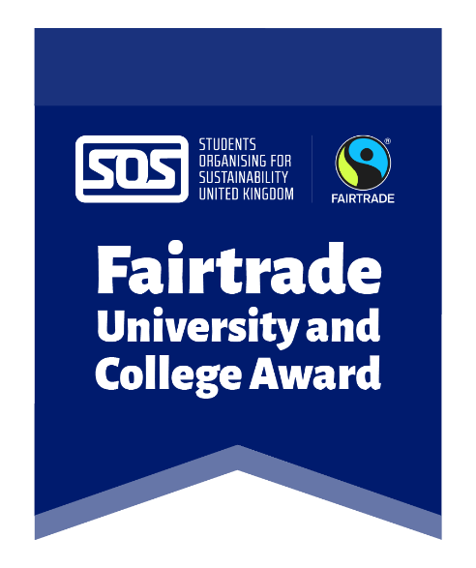
Template copy for newsletters/posting the opportunity on a website

Fairtrade University & College Award Audits - Volunteers needed!

Become an auditor for the Fairtrade University & College Award and help us monitor our progress towards Fairtrade University/College status!

Volunteer auditors conduct an audit of the university to review the efforts to embed and promote Fairtrade and wider ethical consumption. You will receive full training via Zoom, delivered by SOS-UK and the Fairtrade Foundation, where you will learn about trade justice issues and how they apply to the university/college, as well as develop professional and analytical skills. You will learn how to conduct an audit, and then get the opportunity to conduct the audit of the university/college with other volunteer auditors.

The Zoom training and the audits will take place over two days. This is an 8-hour commitment - you will need to be available for the full two days to take part:
- Wednesday 30th April, 10am-12pm and 1pm-3pm
- Thursday 1st May, 10-12pm and 1pm-3pm

Find out more and apply through the short form here [INSERT LINK TO FORM], on or before the deadline of Wednesday 16th April. You will hear back from us, if chosen, by 21st April.

Template copy for social media posts

Instagram/Facebook

Calling all students!

Become an auditor for the Fairtrade University & College Award and help us monitor our progress towards Fairtrade University/College status!

Learn about trade justice issues and how they apply to the university/college and how to conduct a virtual/in-person audit in full training provided by SOS-UK (@sosuk_charity) and the Fairtrade Foundation (@fairtradeuk), develop professional and analytical skills, and put your training into practice with other volunteer auditors.

The training and audits will take place over:
- Wednesday 30th April, 10am-12pm and 1pm-3pm
- Thursday 1st May, 10-12pm and 1pm-3pm

You’ll need to be available for the full two days to take part.

Find out more and apply at [INSERT LINK TO FORM] on or before the deadline of 16th April!

Twitter/X

We’re looking for student auditors to assess our Fairtrade Award status! Receive training from @sosukcharity and @FairtradeUK, develop skills, and put your training into practice with other volunteer auditors.

Find out more and apply [INSERT LINK TO FORM]

